**Report On Business Model Canvas**

**Domain:-**

Transforming how we learn, Artificial Intelligence for educational data analytics and quality monitoring.

**Designed By: -**

Sagar Soni

Shabnam Sandhi

Titiksha Devaiya

Sahil Gosaliya

**Team ID: -**

122037 / 8th Semester

**Project Abstract: -**

People learn differently, at different speeds and with different starting points. Artificial Intelligence could usher in a future where we all learn in a much more personalised way. But no educational system in the world can afford a tutor for every child, so this is where AI might be able to step in. Artificial tutors, made to look and sound as much like humans as possible, could take the lead in delivering personalised education.

Business Module Canvas

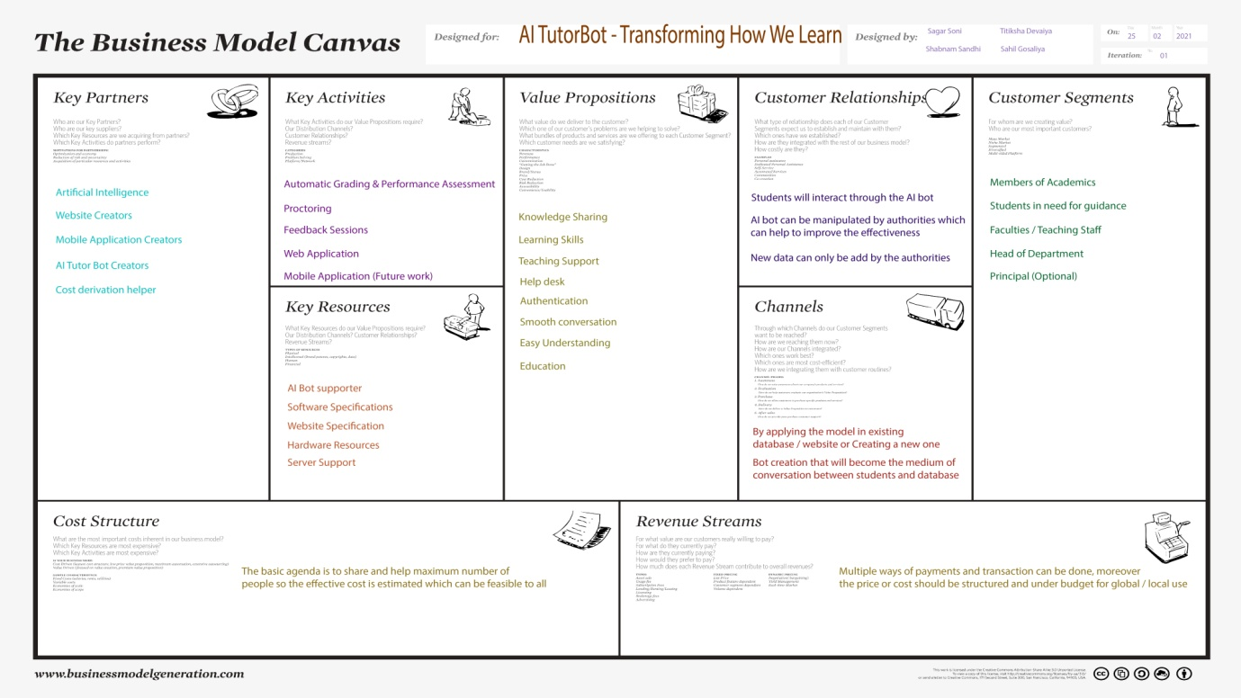

* So basically the BMC canvas describes and distributes the agendas, cost structure and produce development.
* It has variety of sections like Key Partners, Key Activities, Value Propositions, Customer Relationship, Customer Segments, Key Resources, Cost structure and Revenue Streams.
* All the particular sections talks about the different aspects of the product and the domain itself.
* Here is the categorization of all the sections mentioned in BMC:-

**Key Partners:-**

As per out domain suggests that we are focusing of self online learning which will be monitored and controlled by AI tutor bot the key partners will be AI bot creators, website developers, mobile application developer and to estimate the product in market we would also required a product cost planner.

**Key Activities:-**

Key activities are grading and proctoring features during the examinations or tests, a helper which can help the student to find the possible outcomes in easier and much faster fashion than the traditional one.

**Key Resources:-**

Key resources are those which will describe the required hardware and software compatibilities. For example for our AI bot the system should be supportive to the latest technologies like JAVA, XML, SQL etc… with faster RAM.

**Value Propositions:-**

With this project or domain we are proposing the educating yourself in easy way with AI techniques. Like knowledge and skill sharing, help desk or easy understanding and authentication.

**Customer Relationships:-**

Relation between the students and AI bot is defined in our project and to maintain it stronger, this relation should be effective in every manner rather it is by student side or the authority side.

**Channels:-**

We are planning and hoping to implement the model or Bot in any existing system or by creating a dummy one with web application or database to check its effectiveness.

**Customer Segments:-**

The roles that are responsible of implementing the process of this bot falls under the this segment. Like students, faculty, HOD or any higher authority.

**Cost Structure:-**

The basic agenda is to share the knowledge and help the maximum number of people so the effective cost will feasible to all according the selected model of engineering.

**Revenue Streams:-**

Multiple ways of payment methods and mode can be used which exists in real time.